Algebra Proofs:
Inequalities
ERHS Math Club

- Squares are positive x²≥0, Factoring, Quadratics
  - Prove the Arithmetic Mean- Geometric Mean inequality for two variables: 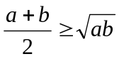 for all a,b≥0.
  - Prove 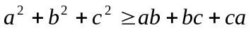 by multiplying by 2 and factoring as squares.
  - Prove that 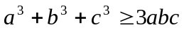 by factoring. Conclude the AM-GM inequality for 3 variables.
  - Find all values of k such that x²+y²≥kxy for all real numbers x and y.
  - Find the largest value of k such that x⁴+4x²y²+y⁴≥k(x³y+xy³) for all real numbers x and y.
  - Prove that x⁴+24x²y²+16y⁴≥8x³y+32xy³ for all real x,y.
  - Prove that if a>b>c>d and a+d=b+c then bc >ad. (Hint: let s=a+b. Factor bc-ad)
  - Prove Aczel’s Inequality: if 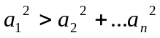 then by considering the determinant of the quadratic
  - [Romanian Olympiad 1983] Let a₁,…a₅ and x,y be real numbers such that . Prove that
  - [IMO 2008/2] Prove that if , and are three real numbers, all different from , such that , then 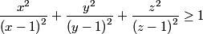.
  - Problem 38 on Olympiad Inequalities
- Power-Mean
  - Prove the Quadratic Mean- Arithmetic Mean Inequality for two variables: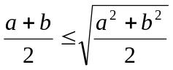 for a, b≥0.
  - Prove the Harmonic Mean- Arithmetic Mean Inequality for two variables: 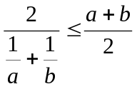 for a,b>0.
  - Prove that 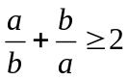 for a,b >0
  - Prove that for a,b>0, 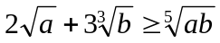
  - Problem 1 on Olympiad Inequalities
  - Prove that 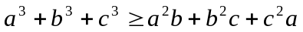 for a,b,c ≥0
  - Prove that for a,b,c>0, 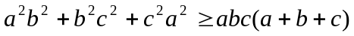
  - Prove that for positive integers m≥n, a,b>0, 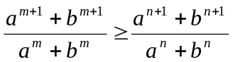
  - Prove that for a,b,c,d>0, 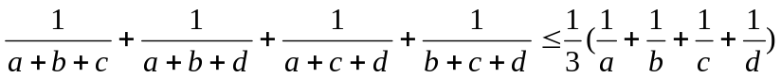
  - A die has 6 sides. Each number has a fixed probability of coming up (not necessarily 1/6). Find the minimum possible probability of getting the same number after rolling it twice.
  - Problem 15 on Olympiad Inequalities
  - Problem 20 on Olympiad Inequalities
- Rearrangement
  - Four boxes contain $10, $20, $50, $100 bills, respectively. You may take 3 bills from one box, 4 bills from another, 5 bills from another, and 6 bills from the remaining box. What is the maximum amount of money you can get?
  - Prove 1(b) by rearrangement.
  - Prove 2(f) by rearrangement.
  - Prove that for a,b>0,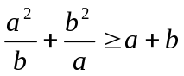
  - (Problem 13 on Olympiad Inequalities) Prove that for x,y,z>0, 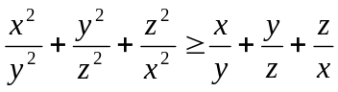
  - [IMO 1978] Let a₁,…a_{n} be pairwise distinct positive integers. Show 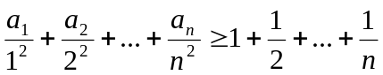
- Cauchy-Schwarz
  - Prove that for a,b>0, 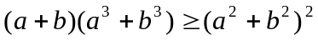
  - Prove that for a,b,c,d≥0, 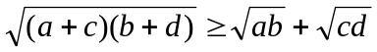
  - Prove that for a,b,c,d>0, 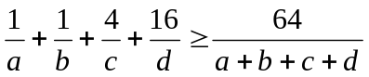
  - Let x₁,…x_{n}, y₁,…y_{n} be positive reals such that a+b+c+d=1. Prove 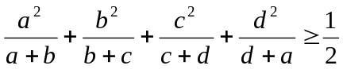
  - Let p be a polynomial with positive real coefficients. Prove that if p(1/x)≥1/p(x) holds for x=1, it holds for all x>0.
  - Show that the sequence a₀,a₁,…a_{n} of positive reals is a geometric sequence if and only if
  - Prove that for all reals a,b,c,
  - Prove that for a,b,c>0,a+b+c=1, 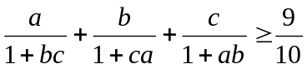
  - [HMMT 2008] Let ABC be a triangle with AB = 5, BC = 4 and AC = 3. Let P and Q be squares inside ABC with disjoint interiors such that they both have one side lying on AB. Also, the two squares each have an edge lying on a common line perpendicular to AB, and P has one vertex on AC and Q has one vertex on BC. Determine the minimum value of the sum of the areas of the two squares.
  - [IMO 2004/4] Let be an integer. Let , , ..., be positive real numbers such that
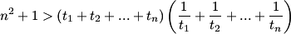.
Show that , , are side lengths of a triangle for all , , with
  - [IMO 1995/2] Let , , be positive real numbers such that . Prove that 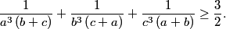
  - [IMO 2004/5] Let be a positive integer and let be real numbers.
Prove that
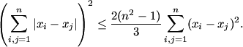
Show that the equality holds if and only if is an arithmetic sequence.
  - Problem 6 on Olympiad Inequalities
  - Problem 12 (uses Holder’s Inequality)
  - Problem 26

